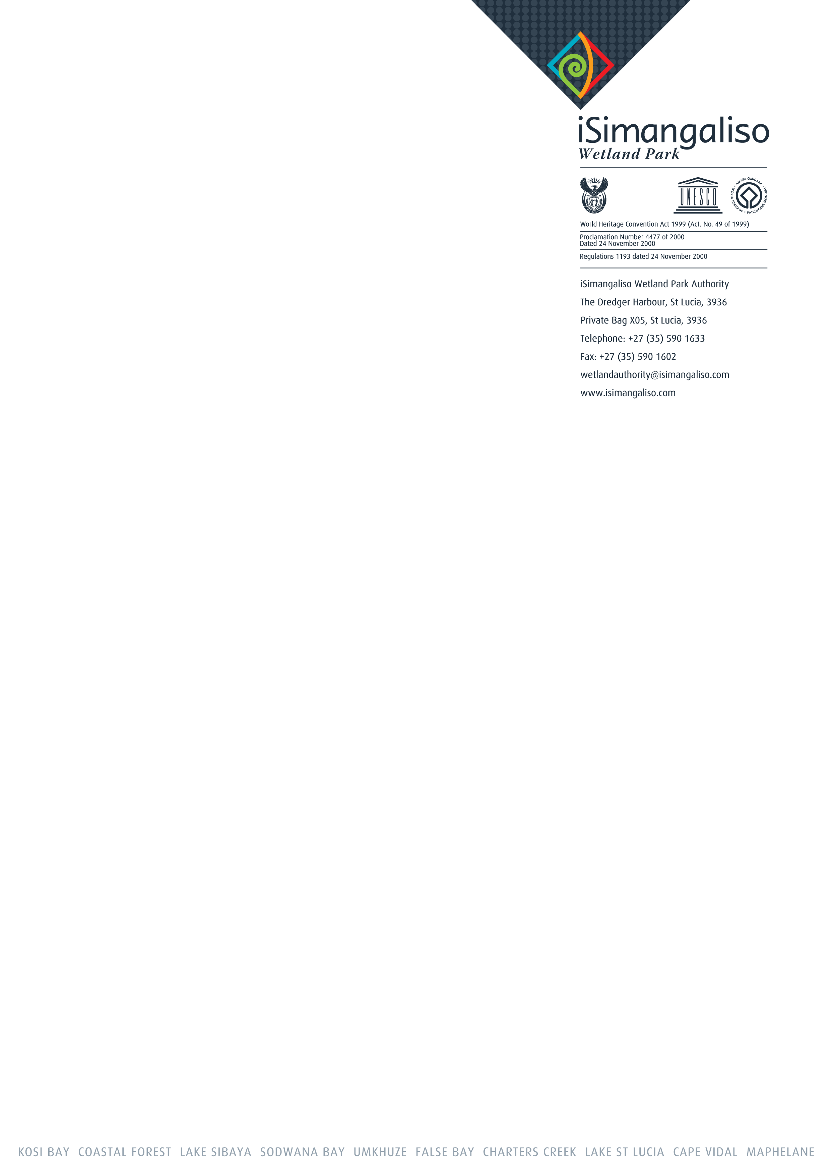

iSIMANGALISO TERTIARY EDUCATION SUPPORT PROGRAMME

APPLICATION FORM

UNDERGRADUATE STUDY in 2023

iSimangaliso Wetland Park Authority: Tertiary Education Support Programme Requirements:

- Students must be registered for a first year of study only in the following institutions: University of KwaZulu Natal, University of Zululand, Mangosuthu University of Technology and Durban University of Technology.

- Students must apply for the National Student Financial Aid Scheme and have confirmation that they have been awarded the NSFAS Bursary for 2023.

- Students must be registered for a course in Conservation, Tourism or Development related programme NOT LIMITED TO ( Conservation, Social Sciences , Development Studies, Tourism, Finance, IT, HR, Engineering, Infrastructure and Supply Chain Management etc).

- The student is a South African citizen who is a verifiable member of either; the Land Claimants Communities of iSimangaliso Wetland Park or a resident of the UMkhanyakude District Municipality within areas that are close to iSimangaliso Wetland Park or the Mfolozi Local Municipality particularly the Sokhulu area.

- Attach Proof of registration, proof of NSFAS, ID copy and Proof of residence.

Closing date: 15 February 2023
Enquiries: 035 590 1633
Email application to: nosipho@isimangaliso.com

Surname

First names
Identity number

Date of birth |  | year |  |  |  |  |  |  | month |  |  |  |  |  |  |  |  |  | day
Postal address |  | Postal code:
Are you a member of a land claimant community?  (Please tick one appropriate answer) |  | Yes |  |  |  |  |  |  |  |  |  |  | No
 |  | Please attach an official letter from the Chairperson of the Board of Trustees of your land claim Trust confirming that you are a member of the land claim community)
If yes, which one?

Are you a member of iSimangaliso’s neighbouring communities?  (Please tick one appropriate answer) |  | Yes |  |  |  |  |  |  |  |  |  |  |  | No
 |  | Please attach an official letter from your local leader / counsellor confirming that you are from the area and the length of time you have been living there)
If yes, which one?
Remember to attach certified copies of:
- Your bar coded ID document or proof of application and either
- An official letter from the Chairman of your land claimant trust certifying that you are a member of the land claim community, or
- An official letter from your Induna or local councillor certifying where you live and that you have been living there for the last 5 years.
Course(s) applied for:
First choice:
Course
University
Second choice
Course
University
Third choice
Course
University
Have you applied for a NSFAS bursary?  (Please tick one appropriate answer) | yes |  |  |  |  |  |  |  |  |  |  | no
Have you had a response from NSFAS?  (Please tick one appropriate answer) | yes |  |  |  |  |  |  |  |  |  |  | no
Please attach your NSFAS proof of your application to NSFAS.

Please motivate why you should be considered for an iSimangaliso Bursary. Please include how your career relates to conservation and/or tourism? (no more than 100 words)

